# WeatherPy Analysis Report

Latitude Vs Max Temperature

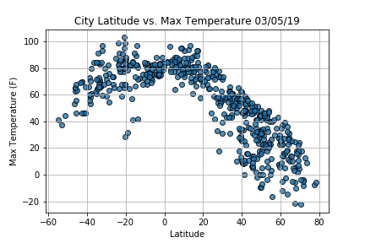

Latitude values are measured relative to the equator and range from -90° at the South Pole to +90° at the North Pole.

The graph represents fairly low count of randomly selected cities in the Southern Hemisphere (Count # 170) vs the randomly selected cities in the Northern Hemisphere is greater in count (376). In March, this time of the year, the Northern hemisphere (latitude > 0°) is cooler than the Southern hemisphere (latitude < 0°) . Also cities around the equator (latitude = 0°) have hotter climate.

Latitude Vs Humidity

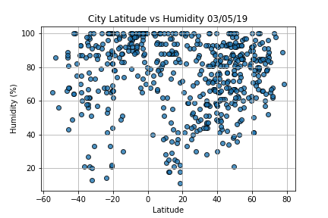

The graph shows Humidity data scattered across entire range of Earth’s latitude. The majority of the cities generated from the analysis had humidity levels greater than 60%. The humidity is affected by winds and by rainfall. The most humid cities on earth are generally located closer to the equator, near coastal regions. There could be a possibility that the majority of the cities in this data set could be in close proximity to water bodies.

Latitude Vs Cloudiness

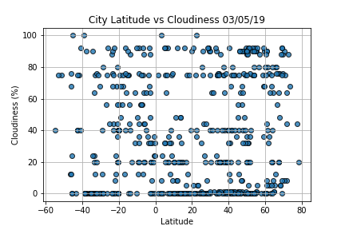

This Graph also shows no relationship between latitude and Cloudiness.

Latitude Vs Wind Speed

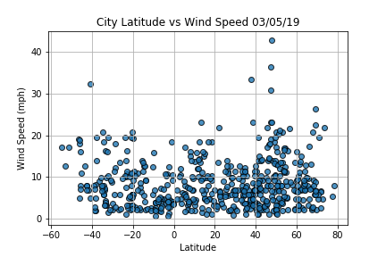

This data set shows majority of the wind speeds <10 mph, indicating that this time of the year, the Atlantic or Pacific or any Other Basin Hurricane Season is not officially begun. Historically, during the Hurricane/Storms/Cyclones period, most tropical cyclones form from June to November each year. Wind Speed is basically measure of air moving from high to low pressure, usually due to changes in temperature.